Shrinkage correlation: EURUSD and NZDUSD
Method 08 / eight-major panel / delta = 0.2 and Ledoit-Wolf / Alpari D1 full available history

Study setup
Logical pair: EURUSD , NZDUSD
Broker symbols: EURUSD_i , NZDUSD_i
Snapshot: 2026-11-03_majors_alpari_D1
Timeframe: D1
Common eight-major panel window: 1999-01-06 to 2026-11-02 (UTC bar dates)
Panel matched return count n: 7127
Dropped unfinished last bar dated 2026-11-03 UTC after a tick-volume check against the prior complete day.
Fixed shrinkage: delta=0.2, mu=3.9170889e-05 (mean of diag(S))
Ledoit-Wolf estimated delta: 0.0042157642
Panel symbols: EURUSD, GBPUSD, AUDUSD, NZDUSD, USDJPY, USDCHF, USDCAD, EURGBP
Complete matched rows (Excel): EURUSD-NZDUSD_Shrinkage_D1.xlsx
Complete matched rows (HTML table): EURUSD-NZDUSD_Shrinkage_D1_data.html

Method carried forward
Shrinkage blends the sample covariance matrix S of matched daily log returns of close, ln(close_t / close_t-1), toward a simple target, then converts the shrunk covariance into correlations. Quotes are not inverted. This experiment builds one common calendar across all eight majors, forms S with the unbiased n-1 divisor, then reports two shrinkage specs: fixed delta = 0.2 with mu equal to the average sample variance (mu * I target), and sklearn Ledoit-Wolf with its estimated delta. Pair reports pull rho_ij from those panel matrices. Same-panel Pearson r is a side check only. Shrinkage improves conditioning; it is not a cause, not a lead, and not a trading signal.

Results
pearson_r | rho_02 | rho_LW | rho_02_minus_r | rho_LW_minus_r | delta_LW
0.552004 | 0.449617 | 0.54987 | -0.102388 | -0.002135 | 0.00421576

Conclusion
Over the common 7127-day eight-major panel for EURUSD and NZDUSD (broker quote directions unchanged), fixed-delta shrinkage correlation at delta=0.2 is 0.4496 (positive, moderate linear link in this sample). Ledoit-Wolf rho is 0.5499 with estimated delta=0.004216. Same-panel Pearson r is 0.5520 (rho_02 minus r = -0.1024; rho_LW minus r = -0.0021). This does not establish cause, lead-lag, or a lasting trading rule.

Charts
Daily closes
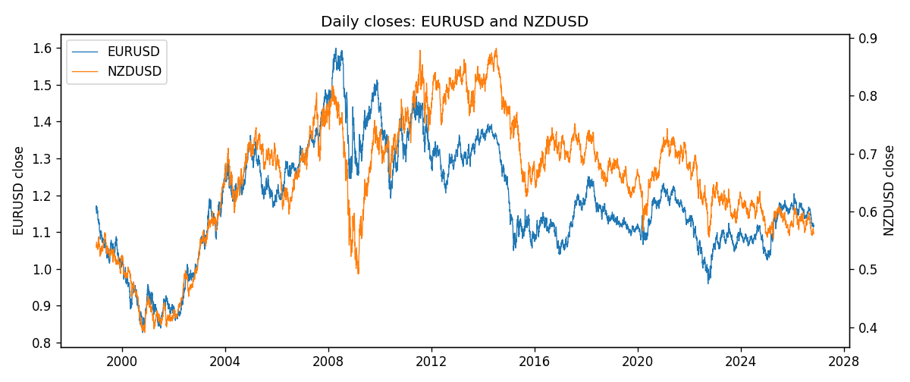
Daily log returns
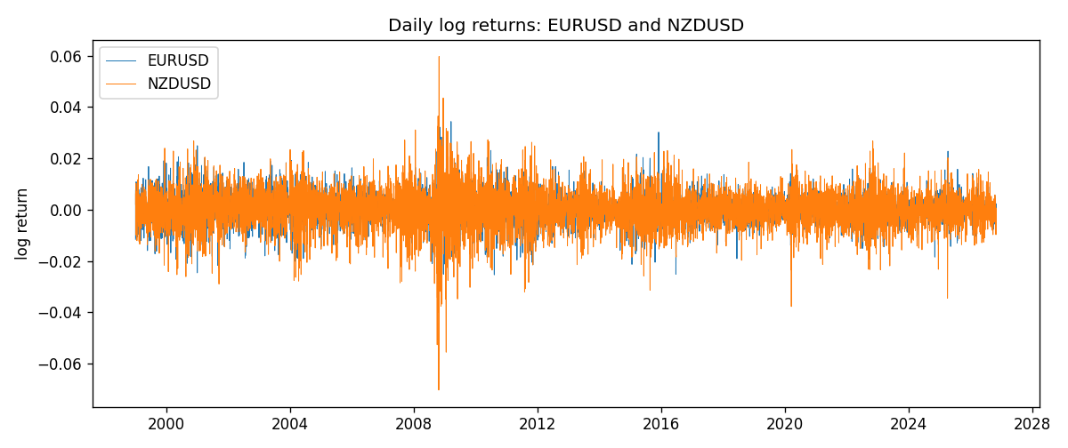
Log-return scatter
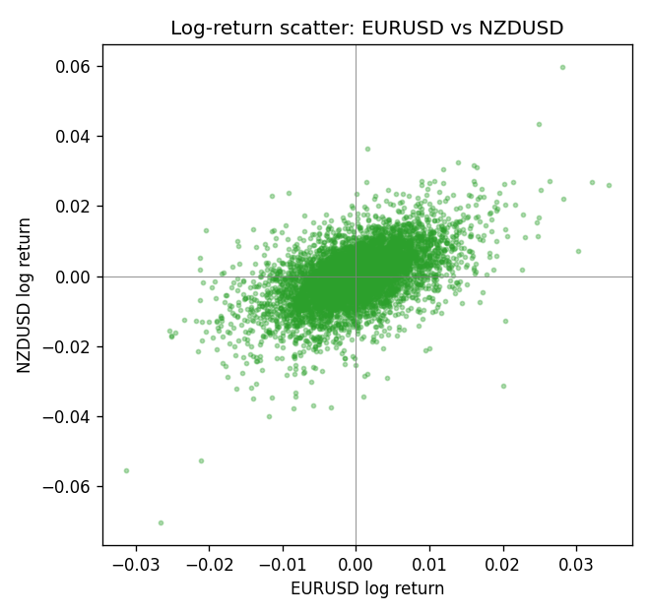

Data report
Every panel row for this pair slice is stored in the sibling Excel workbook named EURUSD-NZDUSD_Shrinkage_D1.xlsx. Full-panel covariance and correlation matrices are saved once under outputs/ as CSV files. Embedding all rows as a Word table is impractical at this length; the Word file holds the column list, column summaries, and the first and last 15 matched rows.
Columns: time, EURUSD_open, EURUSD_high, EURUSD_low, EURUSD_close, EURUSD_tick_volume, EURUSD_spread, EURUSD_real_volume, EURUSD_log_return, NZDUSD_open, NZDUSD_high, NZDUSD_low, NZDUSD_close, NZDUSD_tick_volume, NZDUSD_spread, NZDUSD_real_volume, NZDUSD_log_return
Column summaries (panel rows)
column | count | mean | std | min | 25% | 50% | 75% | max
EURUSD_open | 7127 | 1.1819407 | 0.15065555 | 0.8272 | 1.086455 | 1.16615 | 1.294285 | 1.5995
EURUSD_high | 7127 | 1.1870746 | 0.15125674 | 0.8326 | 1.09055 | 1.17128 | 1.29974 | 1.6038
EURUSD_low | 7127 | 1.1769341 | 0.14996546 | 0.8227 | 1.082375 | 1.16257 | 1.288915 | 1.5865
EURUSD_close | 7127 | 1.1819858 | 0.15061943 | 0.8267 | 1.08652 | 1.16617 | 1.294345 | 1.5997
EURUSD_tick_volume | 7127 | 103994.86 | 174033.72 | 469 | 9542.5 | 53148 | 99923.5 | 1471626
EURUSD_spread | 7127 | 19.176652 | 16.472988 | 0 | 8 | 12 | 20 | 50
EURUSD_real_volume | 7127 | 4.0656436e+10 | 1.6756658e+11 | 0 | 0 | 0 | 0 | 3.6149665e+12
EURUSD_log_return | 7127 | -3.8e-07 | 0.00580028 | -0.03123819 | -0.00324243 | 8.31e-06 | 0.00325629 | 0.03433183
NZDUSD_open | 7127 | 0.65707489 | 0.10792246 | 0.3913 | 0.59224 | 0.66889 | 0.725215 | 0.88218
NZDUSD_high | 7127 | 0.66100044 | 0.10841069 | 0.3961 | 0.595625 | 0.6726 | 0.72964 | 0.88421
NZDUSD_low | 7127 | 0.65338952 | 0.10751648 | 0.3897 | 0.588615 | 0.6651 | 0.721335 | 0.87988
NZDUSD_close | 7127 | 0.65715675 | 0.10791625 | 0.3907 | 0.5923 | 0.66906 | 0.725335 | 0.8822
NZDUSD_tick_volume | 7127 | 69244.396 | 123501.01 | 17 | 5842 | 34224 | 58735 | 1127682
NZDUSD_spread | 7127 | 30.023572 | 25.540824 | 0 | 9 | 17 | 40 | 80
NZDUSD_real_volume | 7127 | 1.6834718e+10 | 8.5315436e+10 | 0 | 0 | 0 | 0 | 2.705649e+12
NZDUSD_log_return | 7127 | 2.447e-05 | 0.00764665 | -0.07027433 | -0.00423198 | 0.00024001 | 0.00459119 | 0.05966839
First 15 panel rows (selected columns)
time | EURUSD_close | NZDUSD_close | EURUSD_log_return | NZDUSD_log_return
1999-01-06 | 1.1623 | 0.5383 | -0.011547966 | 0.0020455609
1999-01-07 | 1.1712 | 0.5417 | 0.0076280636 | 0.0062963171
1999-01-08 | 1.1585 | 0.5414 | -0.010902799 | -0.00055396548
1999-01-11 | 1.1503 | 0.547 | -0.007103287 | 0.010290425
1999-01-12 | 1.1555 | 0.5441 | 0.0045103728 | -0.0053157489
1999-01-13 | 1.1681 | 0.5387 | 0.010845346 | -0.0099742238
1999-01-14 | 1.1681 | 0.5386 | 0 | -0.00018564931
1999-01-15 | 1.1563 | 0.5382 | -0.010153245 | -0.00074294208
1999-01-18 | 1.1605 | 0.5372 | 0.0036256946 | -0.0018597736
1999-01-19 | 1.1603 | 0.5382 | -0.00017235436 | 0.0018597736
1999-01-20 | 1.1566 | 0.5404 | -0.0031939256 | 0.0040793678
1999-01-21 | 1.1601 | 0.5426 | 0.0030215416 | 0.0040627941
1999-01-22 | 1.1587 | 0.5361 | -0.0012075213 | -0.012051689
1999-01-25 | 1.1552 | 0.5342 | -0.0030251979 | -0.0035504102
1999-01-26 | 1.1562 | 0.5381 | 0.00086527651 | 0.0072741158
Last 15 panel rows (selected columns)
time | EURUSD_close | NZDUSD_close | EURUSD_log_return | NZDUSD_log_return
2026-10-13 | 1.11965 | 0.56127 | 0.0037402957 | 0.0047326165
2026-10-14 | 1.11545 | 0.55918 | -0.0037582255 | -0.0037306483
2026-10-15 | 1.12172 | 0.56185 | 0.0056053107 | 0.0047634855
2026-10-16 | 1.12371 | 0.56509 | 0.0017724895 | 0.0057501001
2026-10-19 | 1.12086 | 0.56616 | -0.0025394633 | 0.0018917133
2026-10-20 | 1.12354 | 0.56827 | 0.0023881672 | 0.0037199341
2026-10-21 | 1.12318 | 0.57003 | -0.00032046717 | 0.0030923331
2026-10-22 | 1.12139 | 0.56815 | -0.0015949606 | -0.0033035227
2026-10-23 | 1.11989 | 0.56991 | -0.001338521 | 0.0030929853
2026-10-26 | 1.11735 | 0.56826 | -0.0022706559 | -0.0028993932
2026-10-27 | 1.11272 | 0.56811 | -0.004152342 | -0.00026399852
2026-10-28 | 1.1152 | 0.56261 | 0.0022262927 | -0.0097283914
2026-10-29 | 1.11772 | 0.56296 | 0.0022571351 | 0.00062190714
2026-10-30 | 1.11644 | 0.56307 | -0.0011458446 | 0.00019537668
2026-11-02 | 1.11881 | 0.56161 | 0.002120569 | -0.0025962955

